
UNIVERSITYOF ENGINEERING AND

TECHNOLOGY PESHAWAR
CS AND IT DEPARTMENT
Lab Task#02

Name: Ibtisam Ullah
Reg No: 24PWBCS1206
Section: A
Semester: 4th
Session: 2024-2028
Instructor Name: Sir Muhammad
Subject/Course: Web Tech Lab
Assignment Deadline: 27/02/2025

LAB TASK: 02
DELIVERABLE:
Part A: Basic HTML Structure
Exercise 1: Create Basic HTML Document
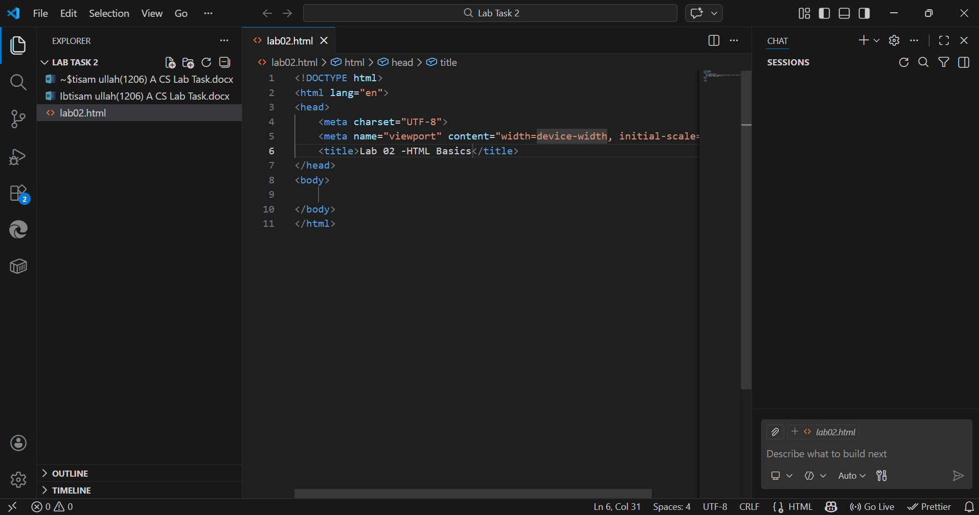

Exercise 2: Working with Text Elements
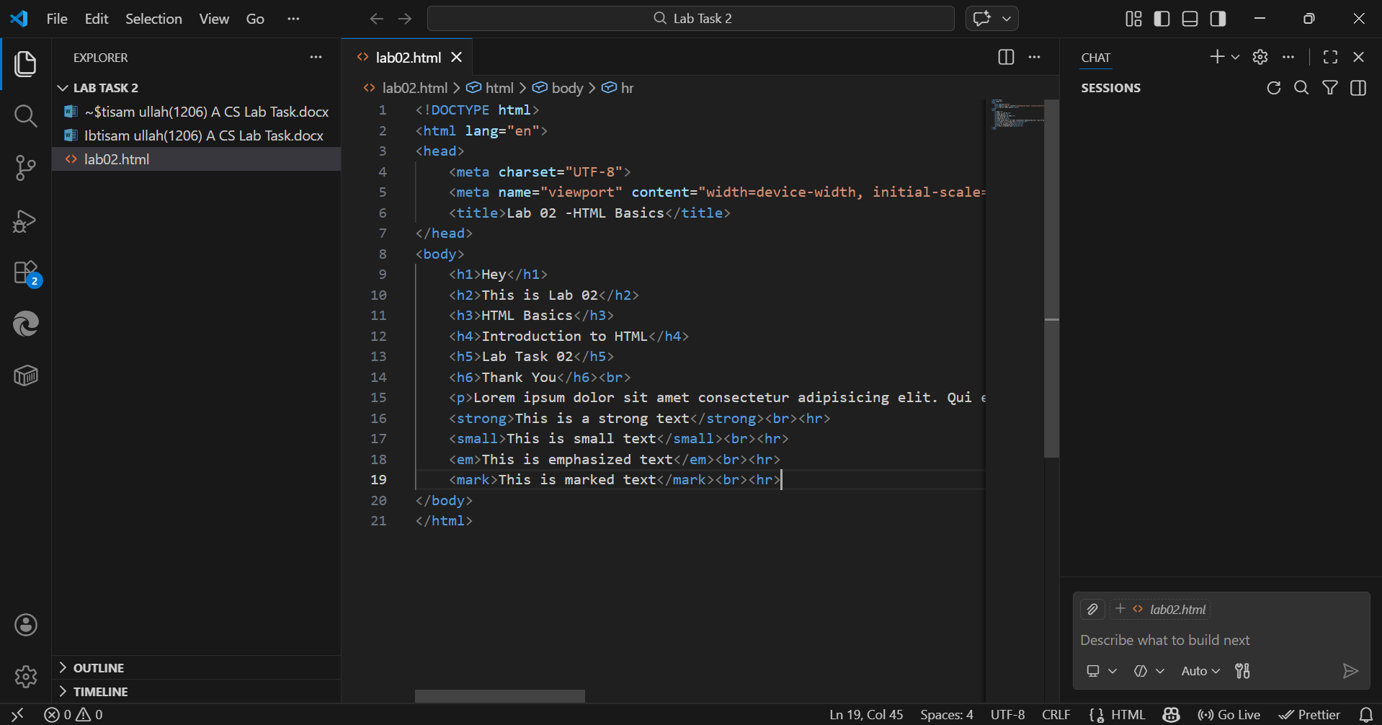
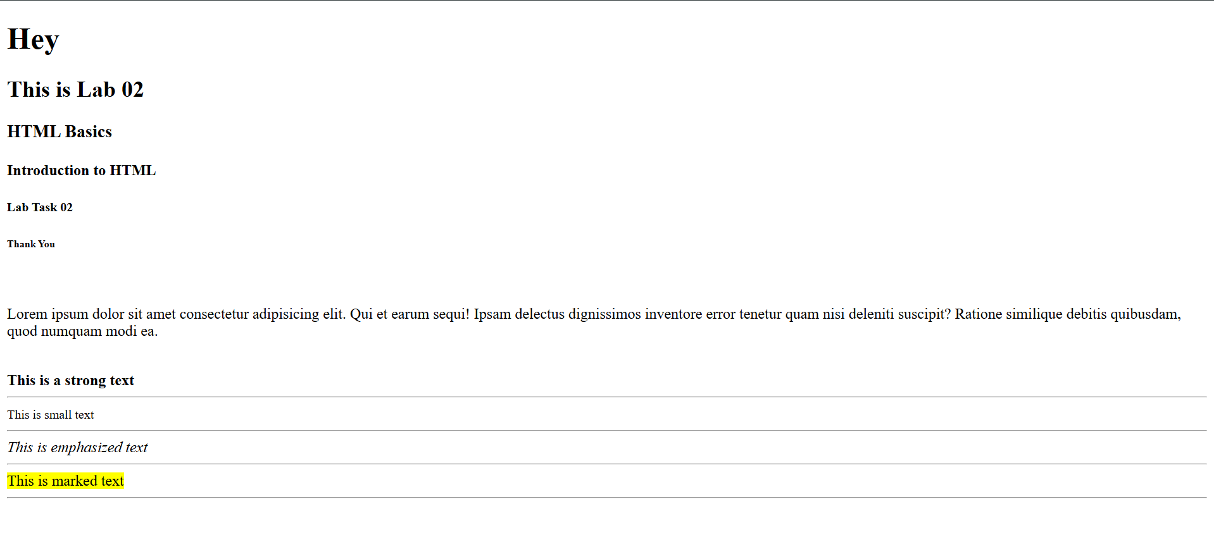
Part B: Links and Images
Exercise 3: Creating Hyperlinks
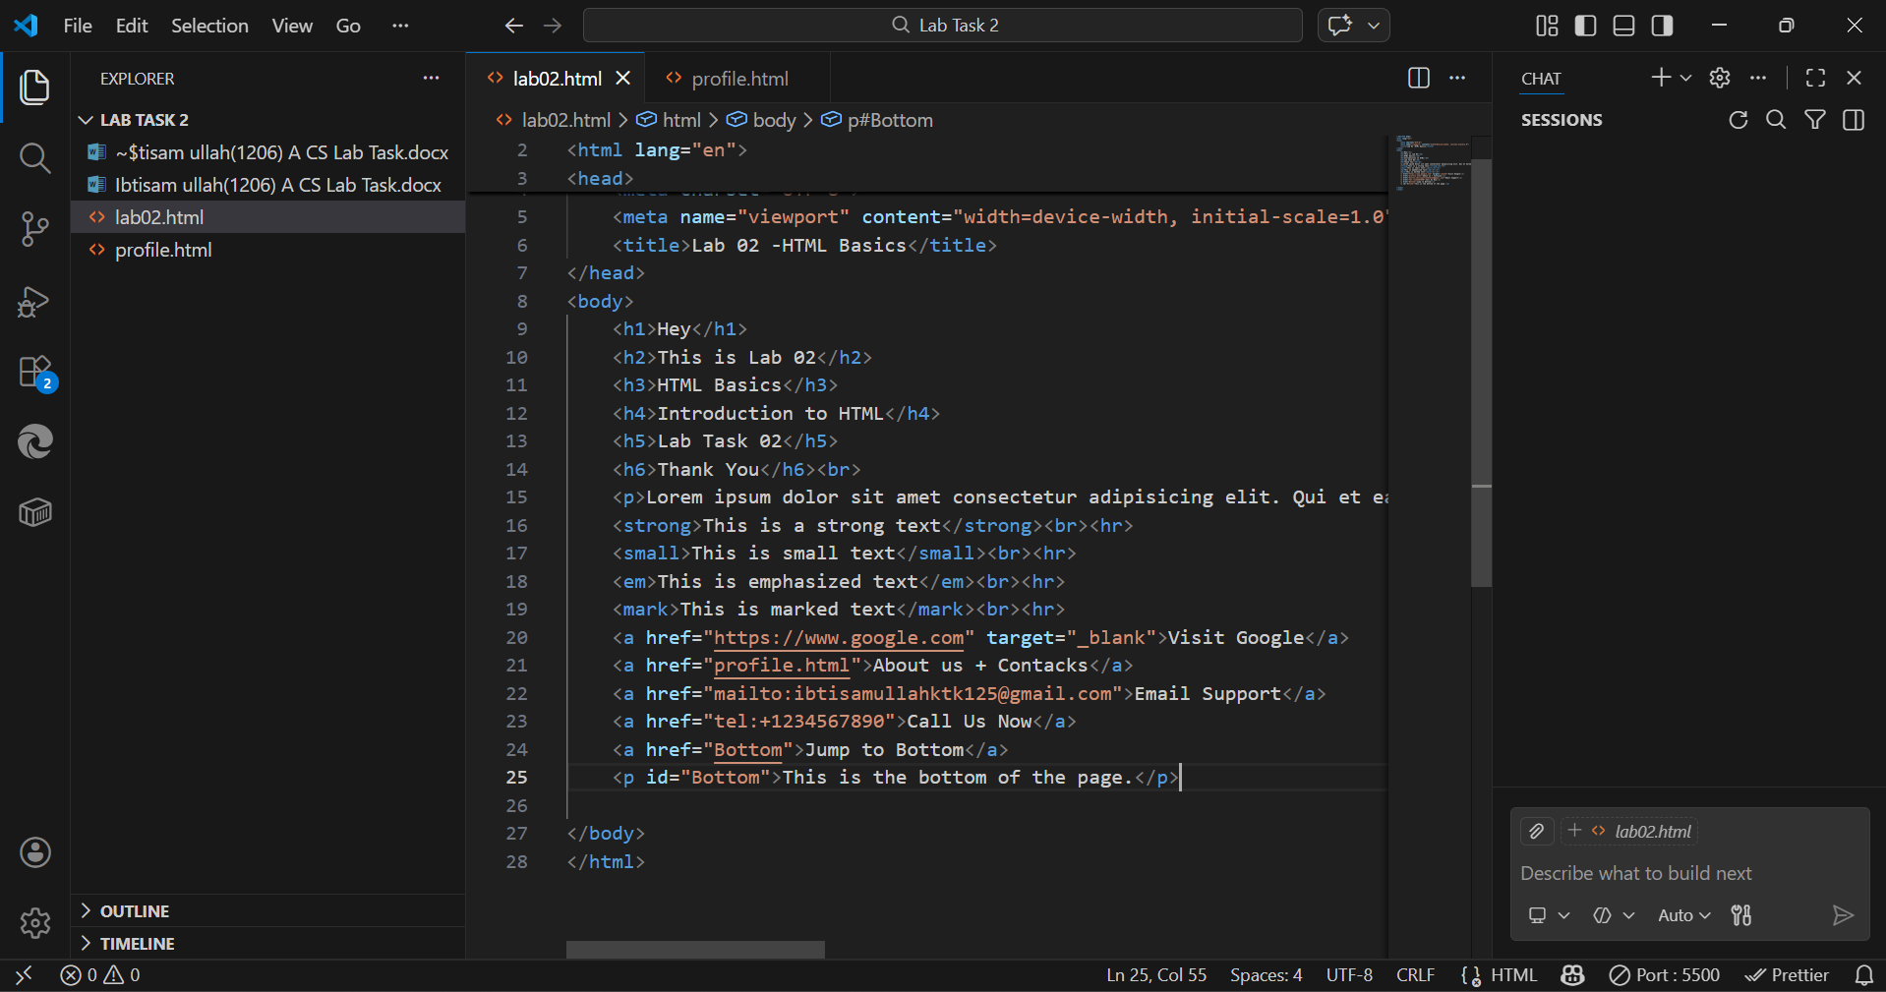
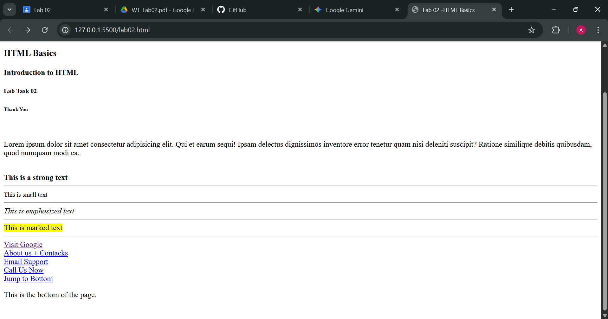
Exercise 4: Working with Images
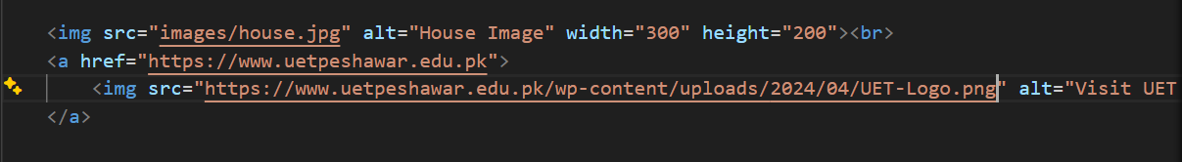
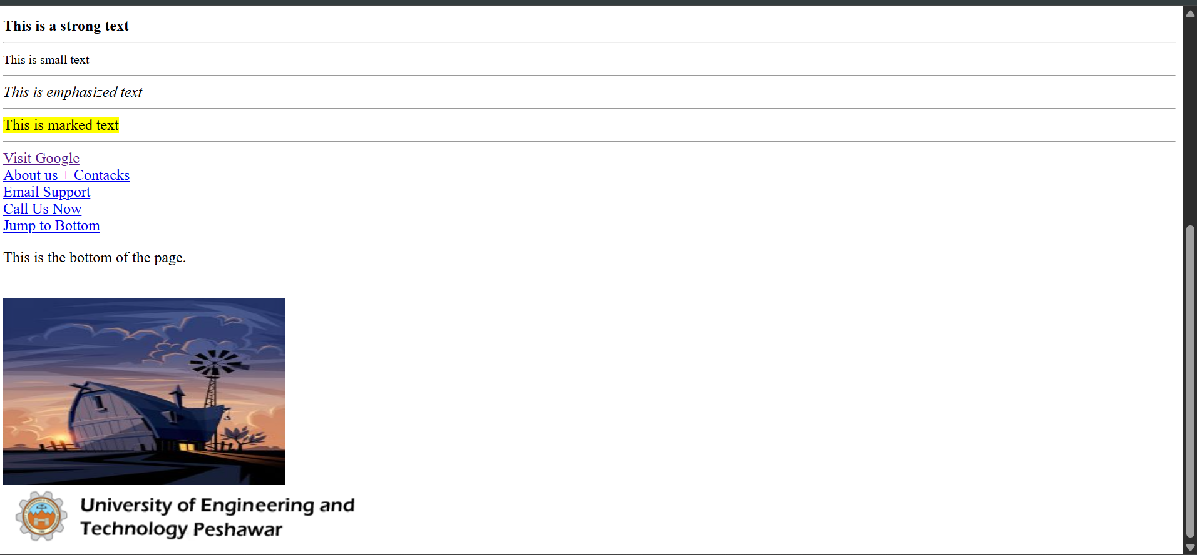

Part C: GitHub Pages Setup
Exercise 5: Enable GitHub Pages
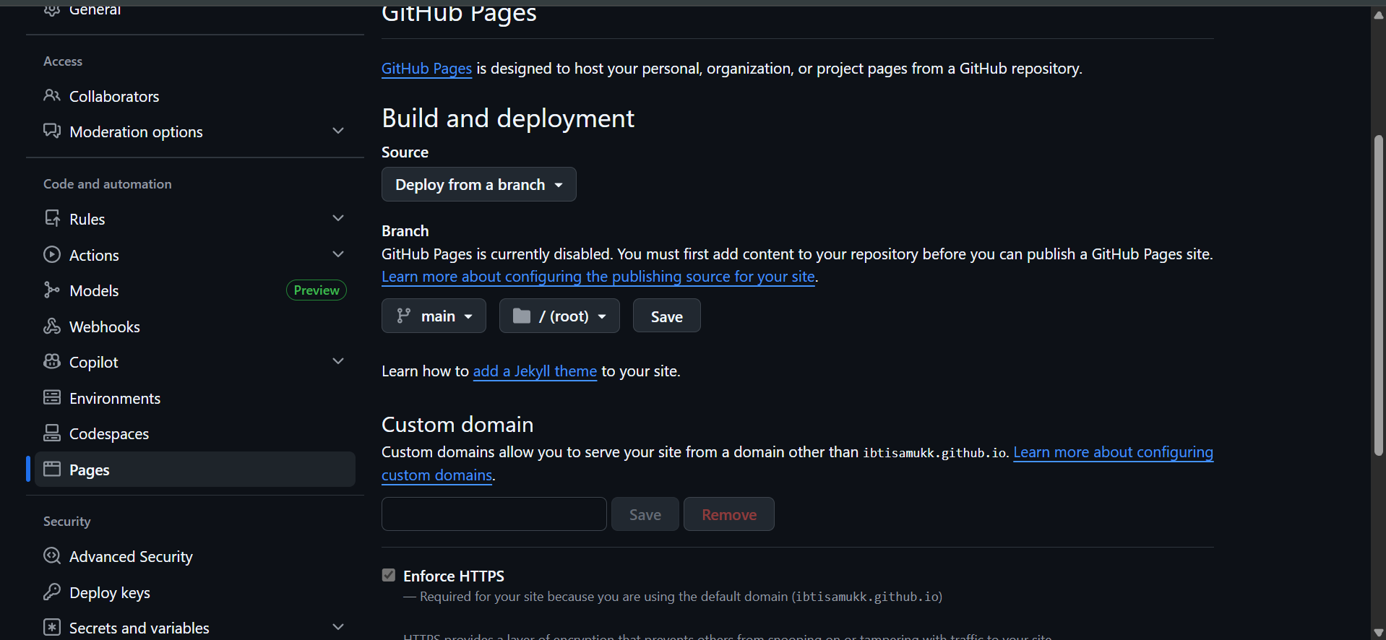

6. Lab Tasks
Task 1: Personal Profile Page
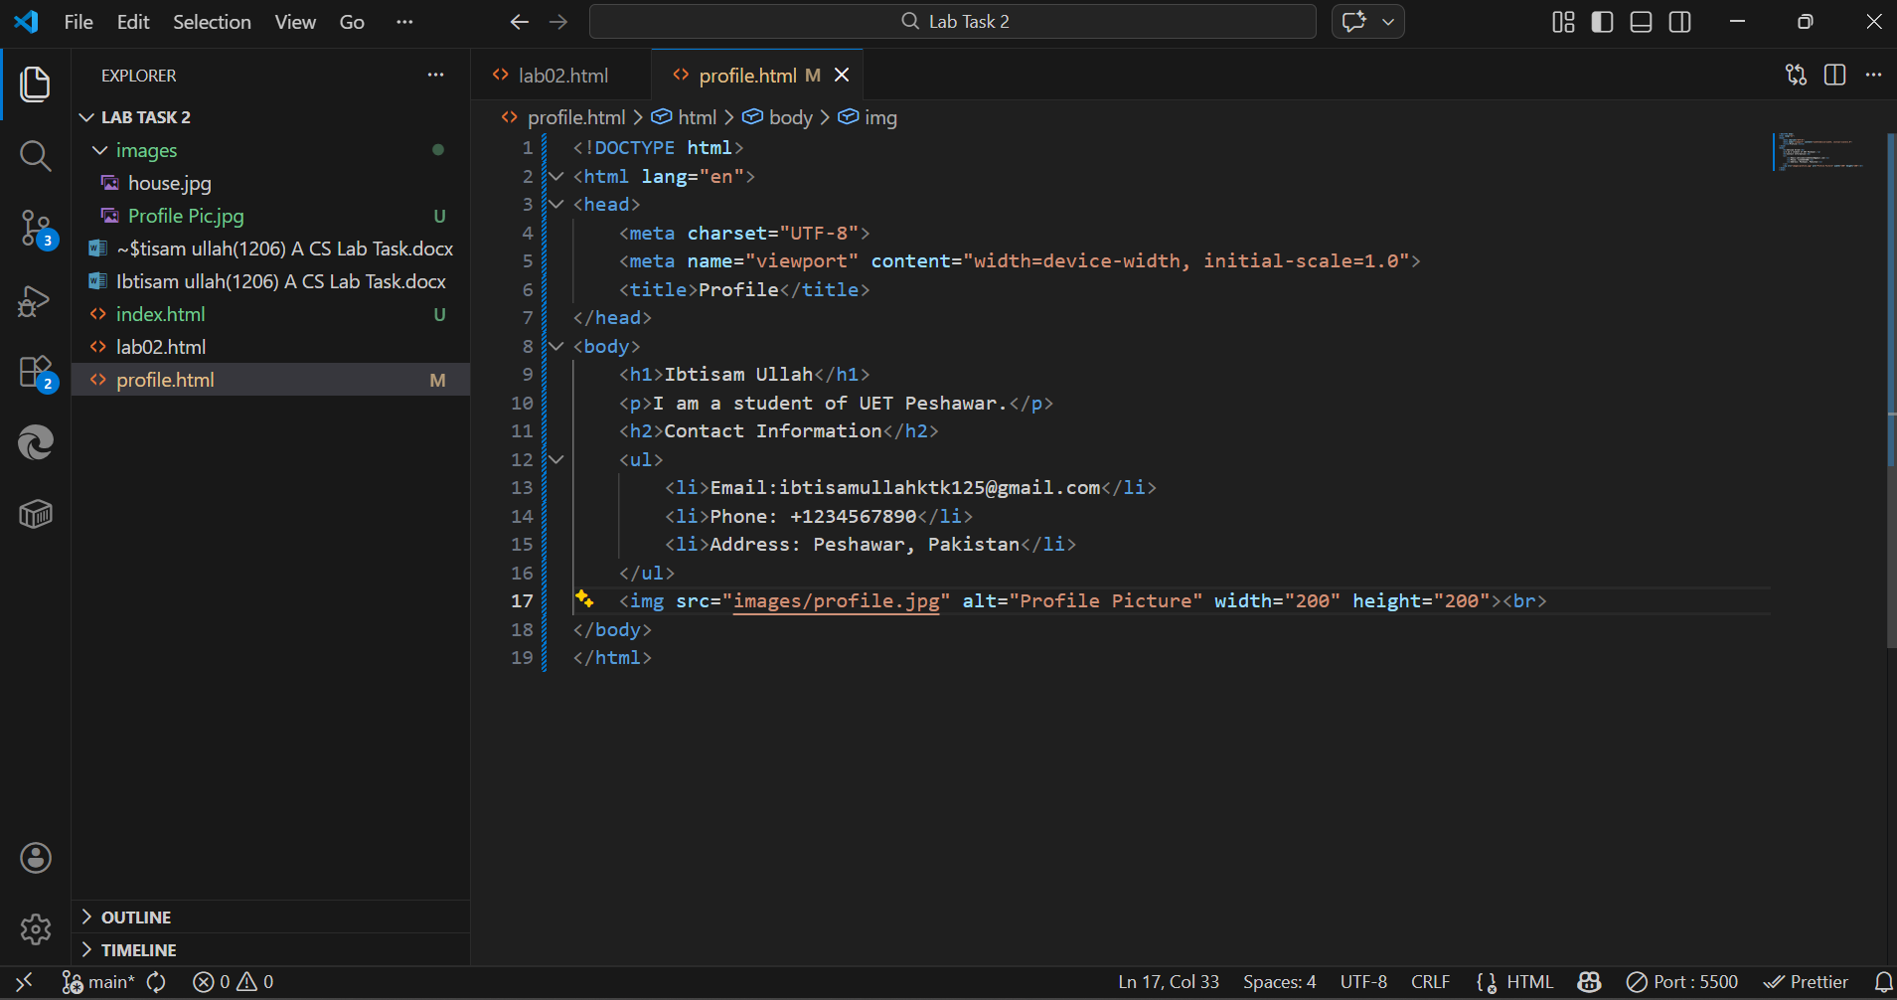
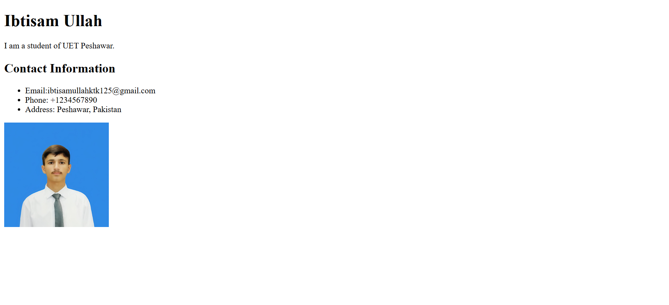
Task 2: Course Schedule Table
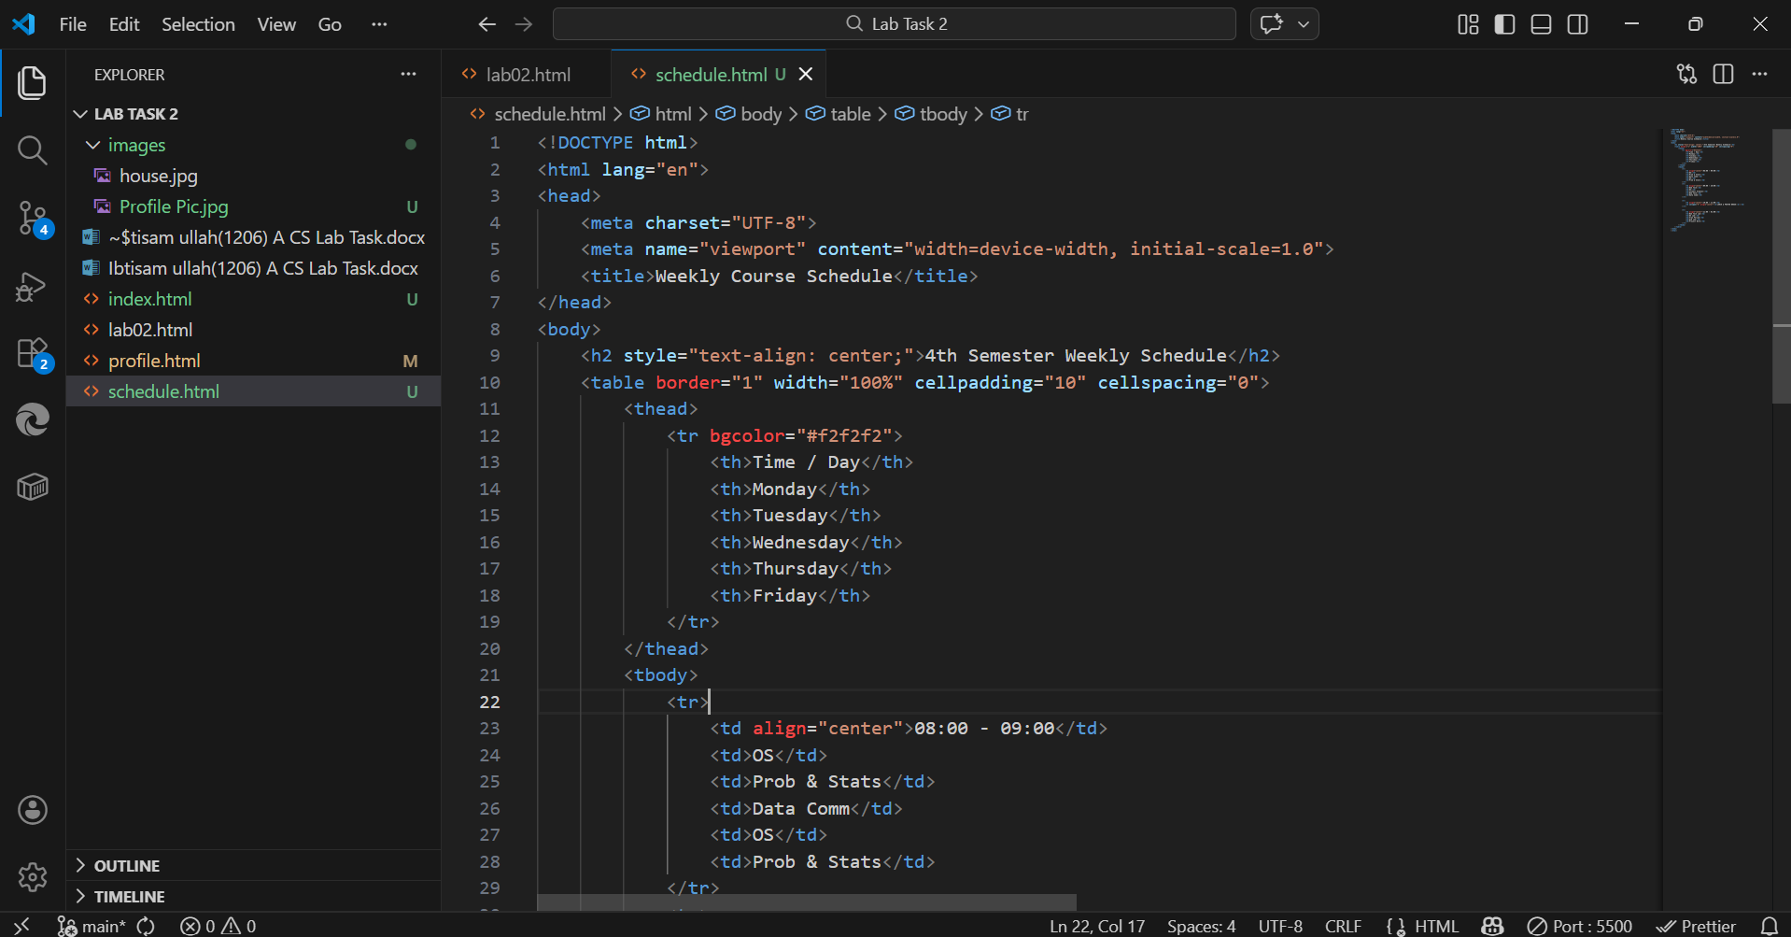
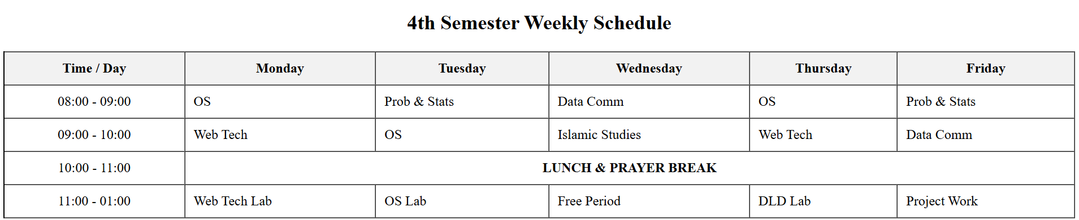
Task 3: Navigation Menu
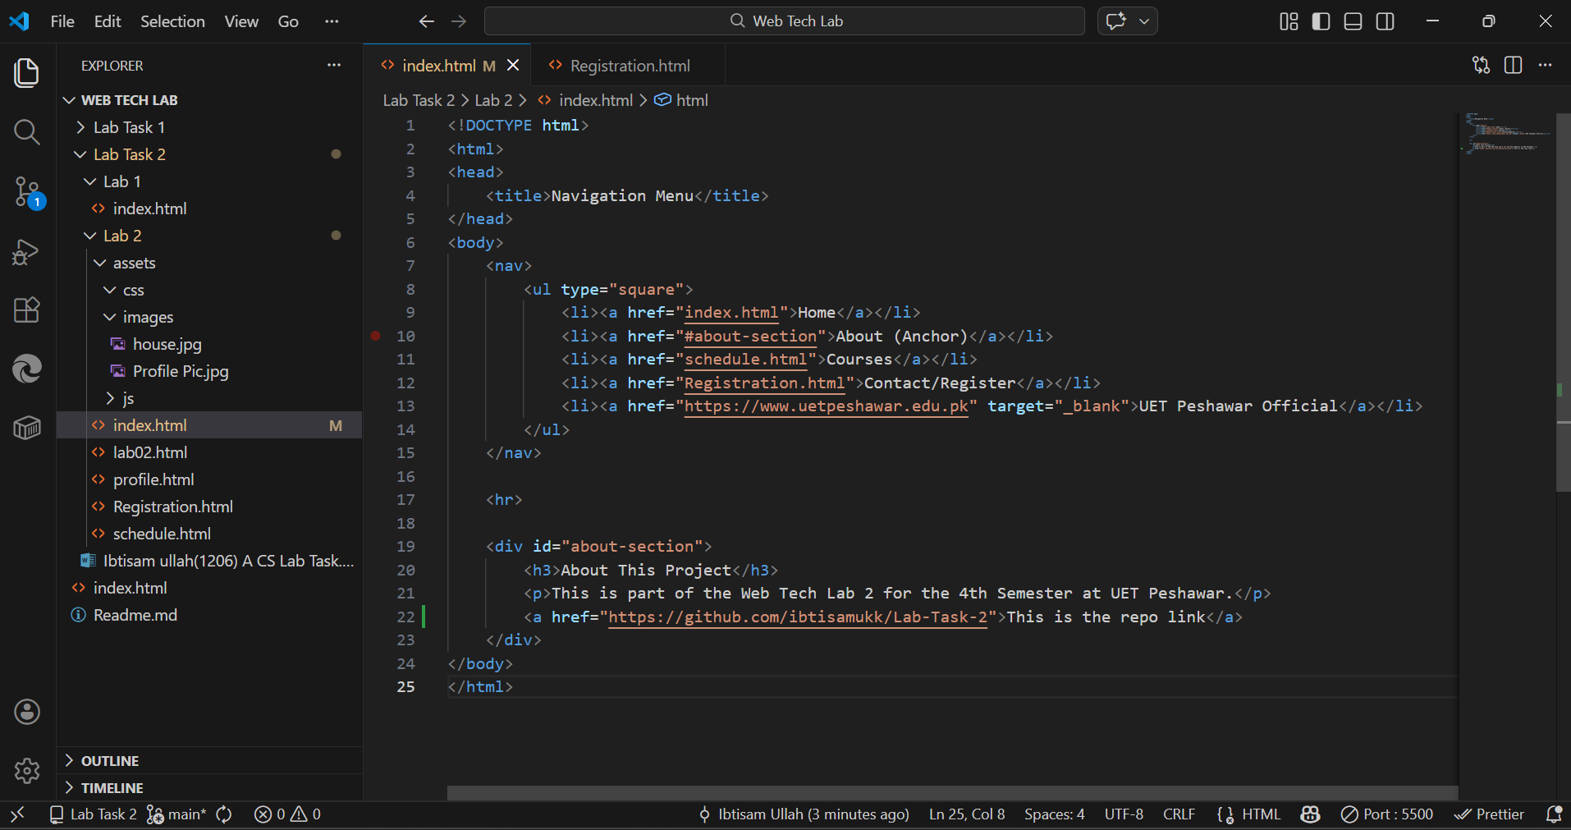
Task 4: Registration Form
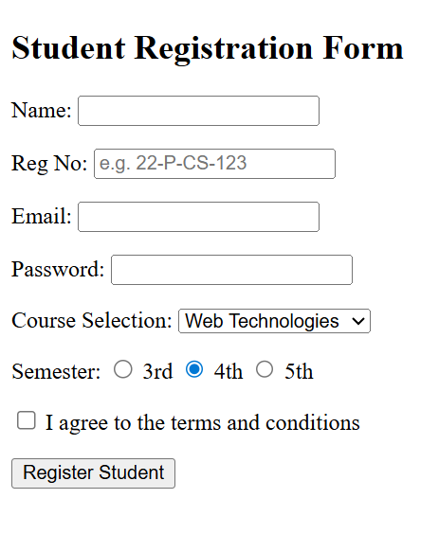

Task 5: GitHub Pages Configuration
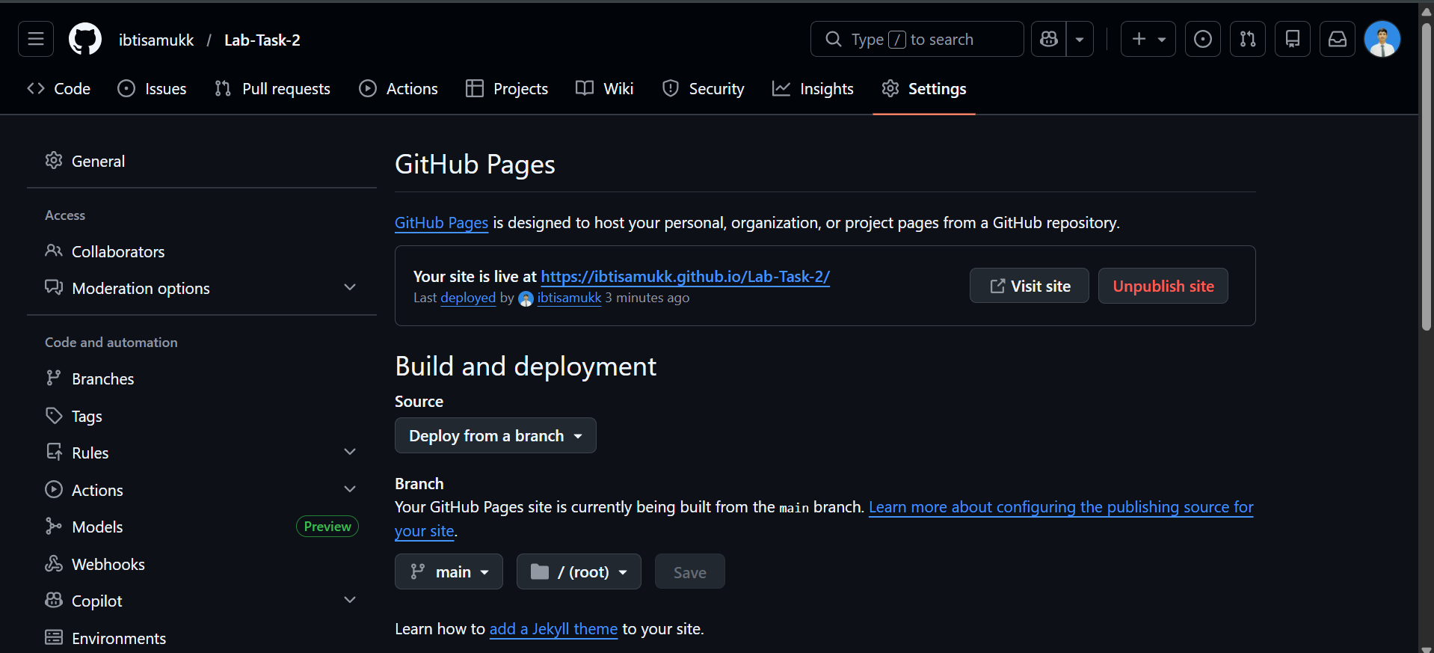

Task 6: Create Landing Page
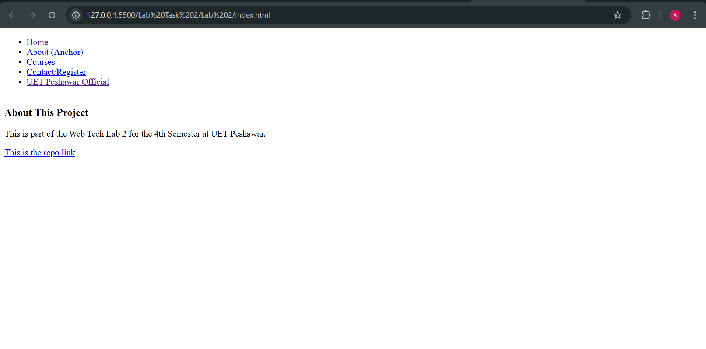

Task 8: GitHub Pages Customization
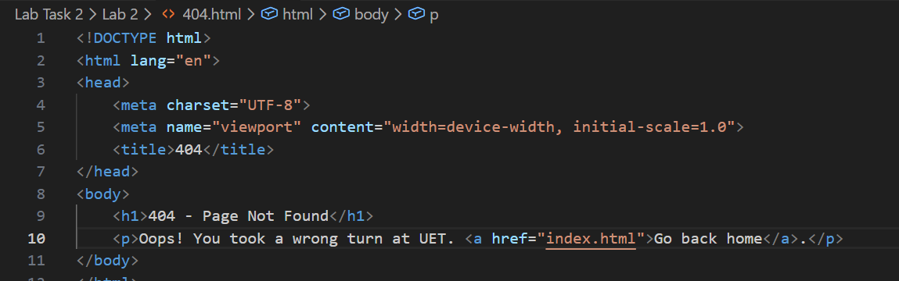

Task 9: Form Handling Setup (Extra Marks)
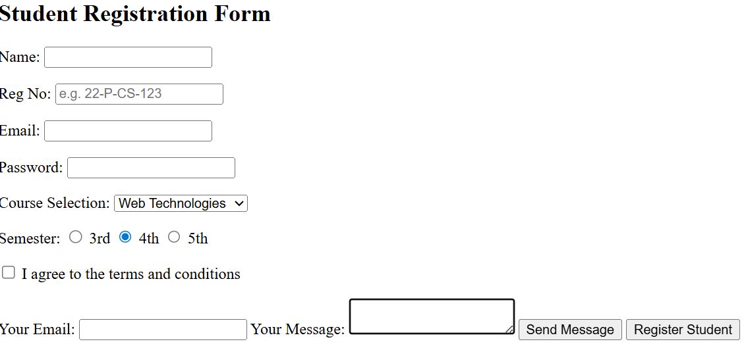

Task 11: Repository Structure Setup
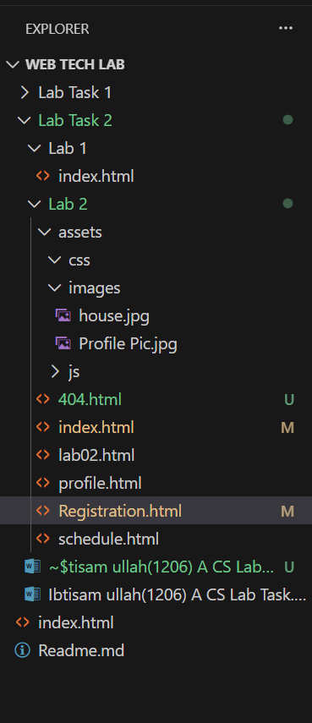

THANK YOU

